LAB Logbook

Lab 1
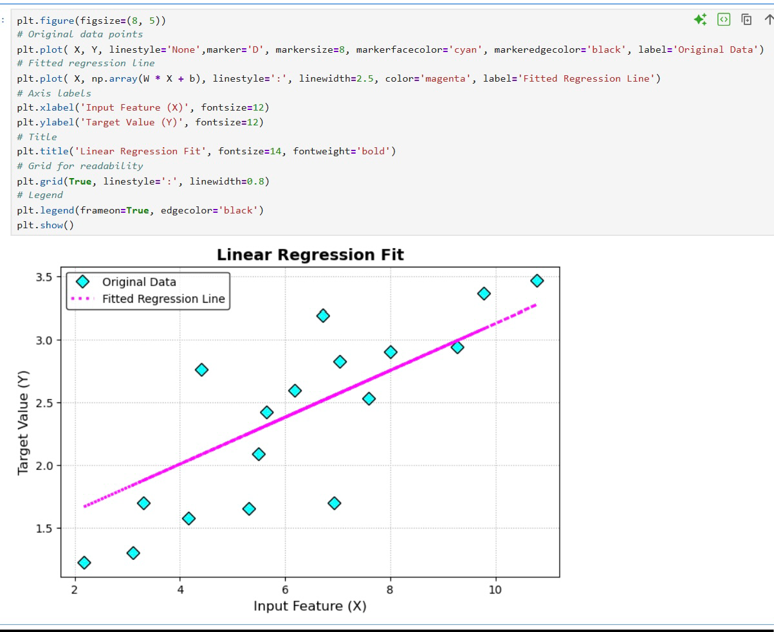
Week 1

